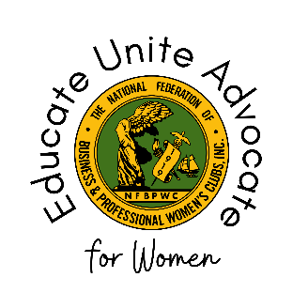

National Federation of Business and Professional Women’s Clubs
Board of Directors Meeting – Executive Committee Report
April 30, 2024
Name and Executive Committee Position:

Members of Your Committee (if applicable):

Did your review of the Bylaws, Policies & Procedures, and/or Advocacy Platform reveal anything to you about what might need to be amended for NFBPWC and/or your committee to operate more effectively or efficiently?

Events of Note [Insert date to date]:

Announcements/Future Events:

Events, Initiatives, or Programs Connected to Sustainable Development Goals (link here: https://sdgs.un.org/goals):

Public Relations/Communications Activities:

Additional information not covered by this report:

