“Ambition In” Post Screening Panels
Ambition In (tech, medicine, architecture, construction, banking, etc.) Panel discussions are an excellent way to take the conversation to the next level. We recommend that you have an interactive run of show that rotates between the moderator asking a question of the panelists and an audience member asking a question.
Run of Show example
Logistics | Date/Time: day, month day, year (pm – pm))  Location:  Attendees:  Seating Capacity:
Event Overview | Event Timeline: example  7 – 7:15 p.m. – Host Welcome Remarks  7:15 – 8:15 p.m. – Pioneers in Skirts movie viewing  8:15 – 9:00 p.m. – Ambition in xxxx Panel Discussion  9:00 – 9:30 p.m. – Audience and Moderator Q&A, Closing Remarks  Secure panelists who have interesting and diverse perspectives and input. The person with the most senior job title may not be the best choice.
Panel Overview | Moderator + Panelists (2-3 more panelists)
Panel Discussion  <You will need a time keeper who will help you to stay on track> | Moderator to open; welcome the panel and introduce the  format for the panel  Look at the audience when the movie ends. You can feel the energy in the room and you will  most certainly see laughing faces. You’ll want to keep the energy going – so try to enter the  stage immediately after the screening. (have panelists mic’d up in advance)  The moderator should briefly introduce her/his self and then welcome the audience and  panelists.  The moderator should very briefly introduce each panelist.  - If the introduction is long, you will lose that energy.  - Please promote each panelist in advance of the screening. Use verbiage that explains why they  are participating in the event (their back story or credentials) and try to have their information  available on a screen. (image, title, social media handles)  - Because the moderator will be brief with introductions, allow each panelist to elaborate on  their purpose on the panel when they are posed with their first question.  Moderator to ask one panelist to share how/why this film is important or relevant to her/him.  Panelists are asked to try to conduct a fluid conversation. The moderator will guide the discussion, but be sure to tell panelists that they should feel free to ask questions too!  Example Question 1: In the film, whose story did you relate to the most? Was there a part that made you think differently about a situation you’ve experienced personally?  Example Question 2: We hear a lot about the social biases imposed on young women and girls in school today. What have you experienced – and what would you suggest needs to be done about it?  Example Question 3: When watching the film, what is the one thing you took away that you wish everyone knew? What do you think would change if everyone knew that?  Action-oriented Lightning Round: Example question -- In one sentence, after seeing this movie, what will you do differently to ensure you’re creating an environment where anyone can be successful?  If time allows, continue with an audience Q&A: Even though you’ve been weaving in and out  between the audience and the moderator, try to open it up to the audience for a Q&A with all  panelists – including the moderator. Ask them to share stories. If men weren’t prominently  asking questions before, say, “I’d love to hear a question from a man in the audience!”  Host to wrap up
Key Contacts | Contact names, telephone, email

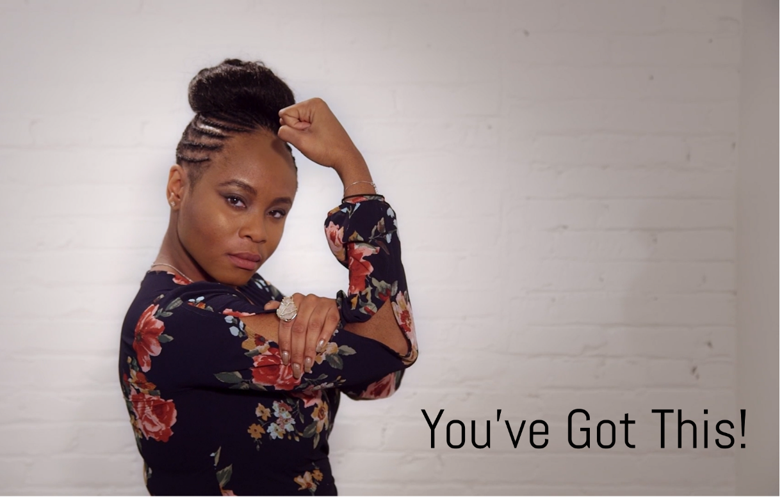

We’re here if you have any questions.
Please contact us at: pioneersinskirts@gmail.com.

