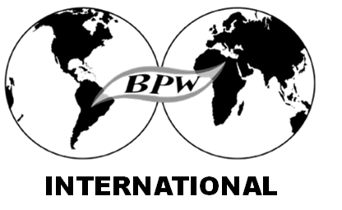
National Federation of Business and Professional Women's Clubs, Inc
2018 General Assembly and IFBPW North America and Caribbean Regional Conference
Sponsor Opportunities
Events
(4) Coffee /Health Breaks $1000 (4 @ $250)
(3) Lunches Sponsor $3000 (6 @ $500)
(1) Gala Dinner Sponsor $6000 (2 @ $3000 or 4 @$1500)
(2) Reception Sponsor $2000 (2 @$1000 or 4x@ 500)
(2) Hospitality Sponsor $1000 (10 @ $100)
Workshops
(7) Workshops:
(1) Leaders Summit $1000 (2@ $500)
(6) Workshop Tracks $ 1500 (6@$250)
Vendors Space
Tables 10 $2500 ( 10 @ $250)
Advertising
Program Book Advertisements Size
Business Card $50.00 3.5 inches x 2 inches
1/4 Page Ad $250.00 4" x 5 "
1/2 Page Ad $500.00 8" x 5" or 4" x 10"
Full Page Ad $1000.00 8" x 10"
Advertising Specifications : jpeg, pdf format 300dpi DEADLINE JUNE 15th
Event and Workshop Sponsors will receive website recognition, print in the sponsored event programs and will be featured in the conference program book
Please mail payments to NFBPWC Treasurer Gloria Flores 13443 Spyglass Hill Ct Horizon City, TX 79928 Payable to NFBPWC
Sponsor / Advertisement Form
DATE:
First name _______________________ Last name ________________________________________

Corporate name :_____________________________________________________________________

Email _________________________ ______________ Phone _______________________________

City _________________________________State ________________________ Zip _____________

Country ____________________________________________________________________________

___________________________________________________________________________________

PARTICIPATION: COST:

□ EVENT _________________________________________________ _________________

□ WORKSHOP _____________________________________________ __________________
□ VENDOR SPACE__________________________________________ __________________
□ ADVERTISING
□ BUSINESS CARD__________________________________________ ____________________
□ 1/4 PAGE AD______________________________________________ ____________________
□ 1/2 PAGE AD_______________________________________________ _____________________
□ FULL PAGE AD_____________________________________________ ______________________
□ ATTACH LOGO ______________YES__________________
TOTAL_____________
Advertising Specifications : jpeg, pdf format 300dpi
ADS SUBMISSION DEADLINE JUNE 15th
□ PLEASE BILL ME Email: ____________________________________
Your invoice will be emailed and can be paid online by credit card or Please mail payments to NFBPWC Treasurer Gloria Flores 13443 Spyglass Hill Ct Horizon City, TX 79928 Payable to NFBPWC
PLEASE RETURN THIS FORM TO : sponsoring@nfbpwc.org

