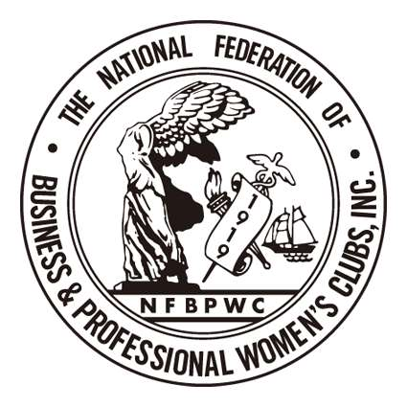
National Federation of Business and Professional Women's Clubs, Inc (NFBPWC)

A Member of the International Federation of Business & Professional Women

NFBPWC
Name:
Address:

Email:

January 29, 2018

The Honorable US Representative
US House of Representatives

Washington, DC 20515

Re: Sexual Harassment of women in the workplace
Dear Representative

As your constituent, I am writing to ask you to support Speier’s H. Resolution 604 and H.R. 4396 which seek to address the issues of sexual harassment and abuse of working women within the Congressional environment.

This bi-partisan legislation should be a beginning toward elimination of the “culture of harassment.”

I am a member of the National Federation of Business and Professional Women’s Clubs which has been the Voice of Working Women since 1919.

I and our membership of five hundred women believe that the current sexual revolution, the MeToo Era, the movement from a Culture of Harassment to a Culture of Change, the Reckoning, is a positive revolution and that this legislation is the current spark in the Congress to motivate change within that body. We will follow the progress of this Resolution and Bill and will support them and hope you will too.

Thank you for your work and dedication these many years.

Very truly yours,

