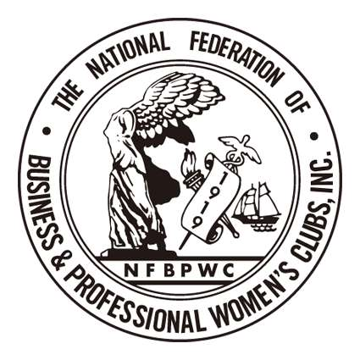
National Federation of Business and Professional Women's Clubs, Inc (NFBPWC)

A Member of the International Federation of Business & Professional Women

NFBPWC
Name:
Address:

Email:

January 29, 2018

The Honorable US Representative Jackie Speier
US House of Representatives
2465 Rayburn HOB
Washington, D.C. 20515
Re: Sexual Harassment of women in the workplace

Dear Representative Speier:

This is to support your H. Resolution 604 and H.R. 4396 to restrain those persons within Congress from engaging in sexual harassment and abuse of working women within the Congressional environment.

Your bi-partisan legislation should be a beginning toward elimination of the “culture of harassment.”

I am a member of the National Federation of Business and Professional Women Clubs, which has been the Voice of Working Women since 1919.

I and our membership of five hundred women believe that the current sexual revolution, the MeToo Era, the movement from a Culture of Harassment to a Culture of Change, the Reckoning, is a positive revolution and that your legislation is the current spark in the Congress to motivate change within that body. We will follow the progress of your legislation and will support it and you in your efforts.

Thank you for your work and dedication these many years.

Very truly yours,

