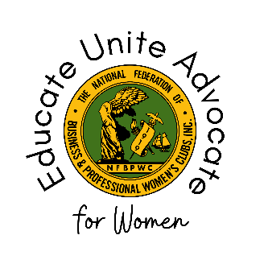

National Federation of Business and Professional Women’s Clubs
Board of Directors Meeting #4 – Committee Report
July 2023
Committee Name:
Name of the Committee Member Submitting Report:
Chair(s):
Committee Members:

Committee Mission (if applicable):

Share one inspired NFBPWC memory that is part of your own herstory in this organization:

Events of Note April 2023 – July 2023:

Announcements/Future Events:

Events, Initiatives, or Programs Connected to Sustainable Development Goals (link here: https://sdgs.un.org/goals):

Public Relations/Communications Activities:

Additional information not covered by this report:

