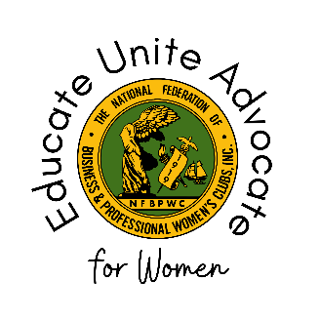

National Federation of Business and Professional Women’s Clubs
Board of Directors Meeting #5 – Committee Report
October 2023
THIS REPORT IS FOR COMMITTEE, SPECIAL COMMITTEE, TASK FORCE CHAIRS ONLY (not EC or Affiliate/Federation Presidents).

Committee Name:
Name of the Committee Member Submitting Report:
Chair(s):
Members of Your Committee (if applicable):

Legacy, Leadership, and Succession Planning
What kind of support do emerging leaders get in this organization? And/or what is missing?

How can we build talent and leadership from within?

Please identify at least 2-5 members as emerging and/or continuing leaders in our organization.

Events of Note July 2023 – October 2023:

Announcements/Future Events:

Events, Initiatives, or Programs Connected to Sustainable Development Goals (link here: https://sdgs.un.org/goals):

Public Relations/Communications Activities:

Additional information not covered by this report:
:

