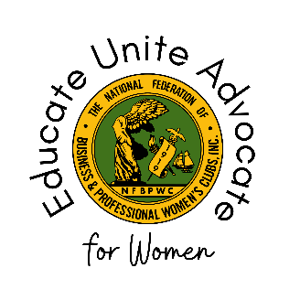

National Federation of Business and Professional Women’s Clubs
Board of Directors Meeting #5 – Executive Committee Report
October 2023
This for is for the NFBPWC Executive Committee Members ONLY (VP Membership, VP Advocacy, Secretary, Treasurer, Young BPW, and Immediate Past President).
Name and Executive Committee Position:

Members of Your Committee (if applicable):

Legacy, Leadership, and Succession Planning
What kind of support do emerging leaders get in this organization? And/or what is missing?

How can we build talent and leadership from within?

Please identify at least 2-5 members as emerging and/or continuing leaders in our organization.

Events of Note July 2023 – October 2023:

Announcements/Future Events:

Events, Initiatives, or Programs Connected to Sustainable Development Goals (link here: https://sdgs.un.org/goals):

Public Relations/Communications Activities:

Additional information not covered by this report:

